Nature Retreat XXVIII

Flying Away

Sermon Outline:

Psalm 55:6—Flying Away

Psalm 55:6 And I said, Oh that I had wings like a dove! for then would I fly away, and be at rest.

Psalm 90:10 The days of our years are threescore years and ten; and if by reason of strength they be fourscore years, yet is their strength labour and sorrow; for it is soon cut off, and we fly away.

I. An Amazing Sight—Starling Murmurations

II. Science—What We “Know”

III. Science—What We Don’t Know

IV. What Scripture Says

V. Wrapping Things Up

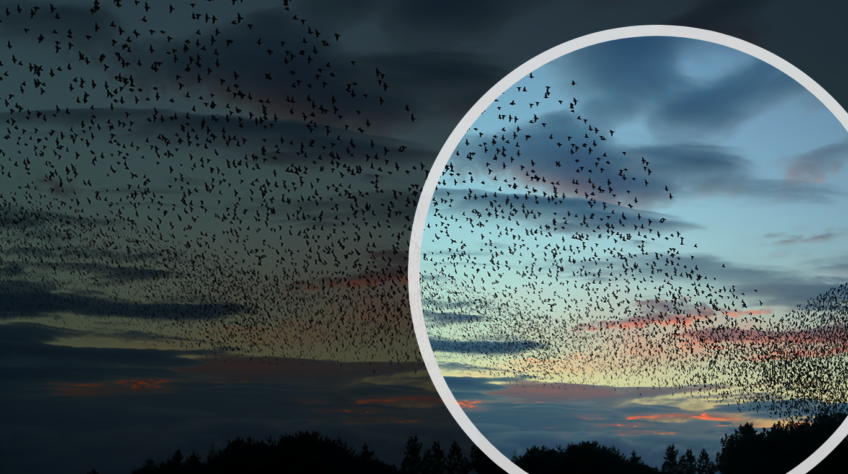

Starlings

In
Flight

21 September 2019

Nature Retreat XXVIII

Water Of Life

Starlings In Flight

Order of Service:

Opening Hymn: Let All things Now Living, CW 260

Reading: Romans 8:19-22

Children: Morning Has Broken

Sermon Hymn: Hymn Of Promise

Sermonette: Psalm 55:6

Flying Away

The Lord’s Prayer

Closing Hymn: God Be With You, CW 327

Nature Retreat XXVIII

We live in an area of intense natural beauty. And it was 26 years ago that Christine and I hit on the idea of sharing our section of God’s Country over an open Bible with Christian friends who had a love for nature and the Word of God.

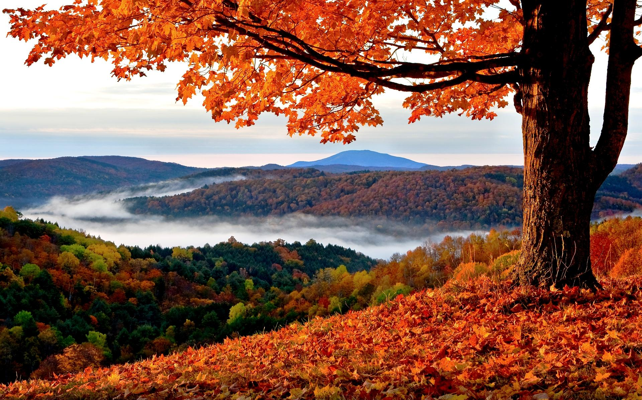

Looking back over the years, there are so many pleasant memories we have of our Nature Retreats. Old friendships have been renewed and new friendships have been formed. And we have been blessed with good weather every single time.

Over the years we have had contact with the hills and the clouds; with the Monarch Butterfly and the Scarlet Worm; with the Sun, Moon, and Stars; with Eagles and the Great Horned Owl; with the Great Pyramid of Egypt; with the Loon and the Arctic Tern; with Ants and Snowflakes; with the Sea and the Northern Lights. The Lord God’s creation, speaking to us from the pages of the Volume of Nature. And from the light found in the Volume of Holy Scripture.

